**Planning**

Software development starts with the planning stage. I needed to do an overall evaluation of the application and did an extensive research about the different development methods, and I found that the Agile method would be the most suitable for this ticketing system as the timeframe is very short and I am the only developer that will be working on the project.

Below is the time plan that will be followed for the stages of software development:

-Define requirements: 1 hour

-Design & Prototype: 4 hours

-Development: 4 days

-Testing: 2 hours

-Submission: 1 hour

**Defining Requirements**

After planning my project, I have done a quick session of defining the overall requirements needed for the application to be functioning as expected; below are the requirements needed:

* A staff member can enter a ticket which contains the staff name, ID, email, as well as a description of the issue.
* The helpdesk staff should have access to all the tickets and be able to respond to any of the tickets and close it, or re-open it if needed.
* A staff member should be able to change the password by entering the words “Password Change” in the ticket’s description.
* Any ticket with “password change” will be set to closed automatically.
* The staff member can end the application anytime.
* The counter of tickets starts with 2000 and increases by one when a ticket gets added.

**Design & Prototyping**

I have used Python3 as the main programming language of the ticketing system and used Visual Studio code as my IDE. I have designed two classes in my system:

1. The Main class contains the main method which shows and interacts with the user and allows him/her to do the commands that are required.
2. The Ticket class contains all the required methods and variables needed that are related to the tickets being created.

**Software Development**

I have added the code of the application to the same folder with a text file explaining how to run the application. I have attached here some screenshots of the application:

Adding tickets

Showing tickets

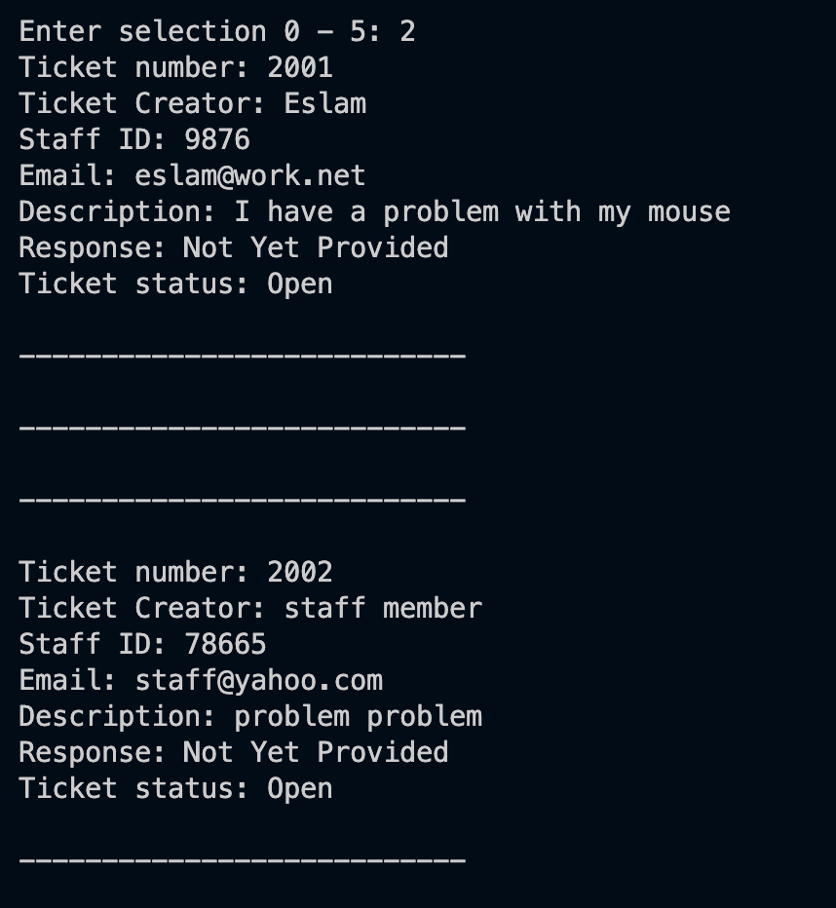

Responding to ticket

Re-opening ticket

Showing stats

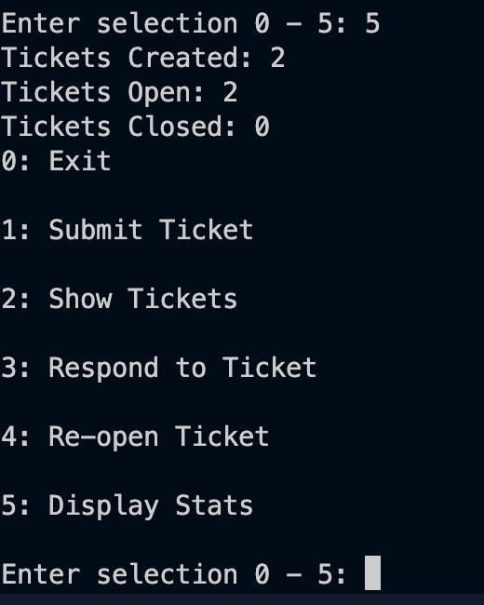

Changing password

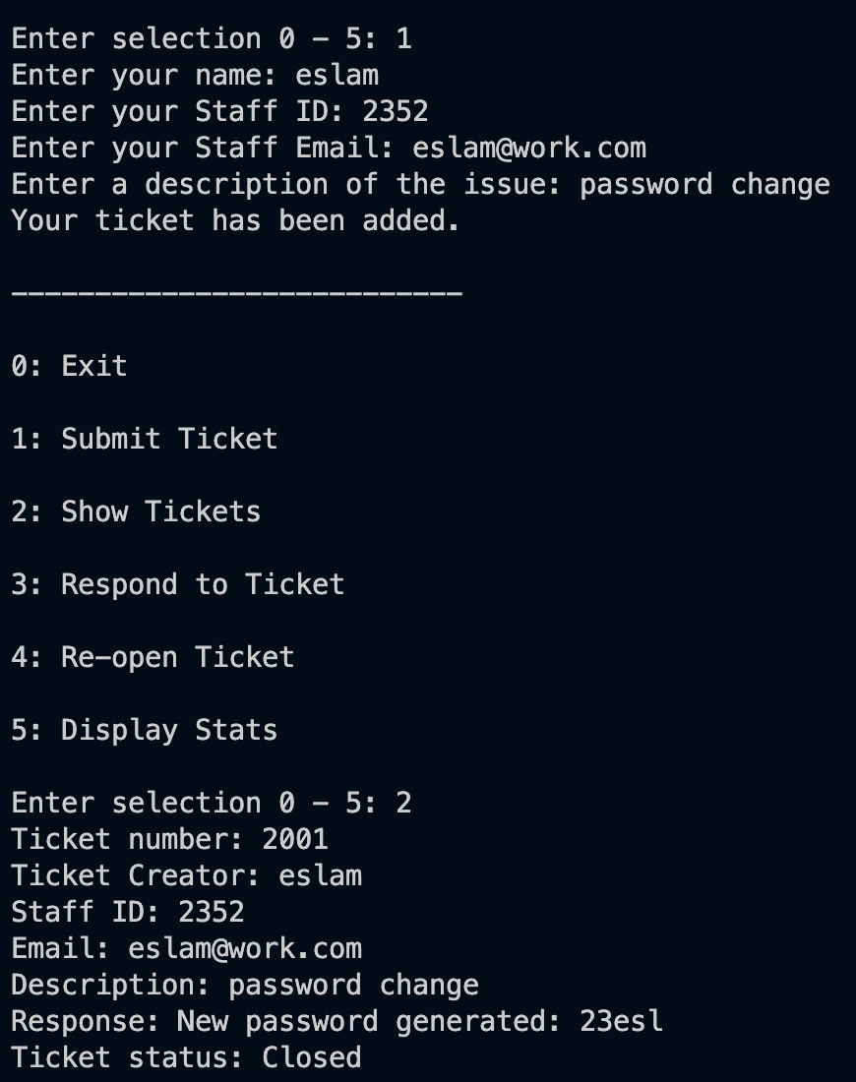

**Testing**

Testing is very important as it ensures that the application is working as expected. I have done testing while working on coding whenever I add a new feature to ensure that is working well. My strategy was to open the terminal and run the application whenever I add a new function and I test it multiple times before moving on to another feature. If the application worked as expected, I would move on to the next feature; however, if it failed, I would look at the terminal and see the logs for errors and aim to fix them before moving on so that I don’t have to deal with accumulated problems. At the end, I did a full trial of the application by adding different data to it and ensuring that all the functionalities and requirements, mentioned above, are working as expected.

**Deployment & Submission**

I have added all the classes to the same folder and then to run the application I opened any terminal on my mac (command prompt for windows users) and ran python3 followed by the path of the my main script, Main.py.